Restaurant Data Analysis

Team Py Squad

Manideep Kandibanda - 11639176

Revanth Kamisetty - 11689974

Srivalli Obulasetty - 11613993

Sai Krishna Reddy Pallerla - 11705851

Omkar Reddy Lakkireddy - 11602672

Information Systems and Technology, University of North Texas

BCIS 5110: Programming for Business Analytics

Dr. Melody White

November 29, 2023

Table of Contents

Contribution to the Project and Report ……………………….. 4

Executive Summary ……………………….. 4

Project Motivation/Background ……………………….. 6

Work Plan ……………………….. 6

Software Requirements ……………………….. 6

Introduction to Libraries

Seaborn Library ……………………….. 7

Folium Library ……………………….. 9

Data Description ……………………….. 10

Data Transformations/ Exploratory Data Analysis ……………….. 11

Checking and Handling Null Values ……………………….. 16

Analysis, Findings, and Managerial Implications ……………….. 17

Conclusion ……………………….. 29

Appendix ……………………….. 30

References ……………………….. 33

Restaurant Data Analysis

In this project, we have used the Restaurant dataset extracted from github.com which is a vast collection of culinary data including offers, prices, and ratings, to lead us on a gastronomic journey using Python. In a world where internet food discovery is the norm, this project uses strategic tools such as NumPy, Pandas, Matplotlib, Seaborn to discover patterns in diverse types of cuisines that are popular in various regions. We document everything in Jupyter notebooks. From finding the best restaurants to making a lot of money in specific regions, we use the science and the art of data analysis and programming. As we discover the secrets of the data driven restaurant analytics industry and gain knowledge of consumer preferences by extracting information from the vast array of food, join us on this journey to understand the nature of culinary tastes, discover the mysteries of the culinary universe and unlock the secrets of the world of data-rich restaurant analytics.

**Contribution to the Project and Report**

As a Group, we made sure to divide the responsibilities of this project in a rightful way. Each member contributed their significant efforts in completing the project. We all researched and came up with different data sets. After long discussion, we all agreed to use Restaurants data. In each group weekly meet we progressed by solving each step starting from gaining knowledge on columns like what are they and what kind of information they are representing in the dataset. Later, framed some questions that can be answered using the data available and documented the findings and answers. You will find more information as you go through the document.

**Executive Summary**

We are currently working on the Restaurant Dataset, which has 20 plus columns and more than 9000 rows. This contains 30% of missing data. This information can be utilized to estimate the number of restaurants in a specific city or nation. Density of restaurants. The average customer ratings determine how restaurants are ranked. Creating price range categories and calculating the number of restaurants in each group. Collecting the number of restaurants that offer table reservations and online delivery. Creating charts based on cuisines, cities, ratings, and other relevant criteria.

To represent this project in a business point of view, we created a scenario where a client approached us saying that he wants to open a restaurant and he needs recommendation on location, facilities, and cuisines he should introduce to open and survive in the restaurant industry.

After thorough analysis and discussions with the client, we made a list of questions to answer that might be helpful to him/her to open the restaurant. The questions are.

* Finding the Number of Restaurants in each country so that we can filter out the best country that are suited to open the restaurant.
* After deciding the country, check the number of restaurants in the city and locality to decide on the location.
* Then checking the density of restaurants in chosen city to check the best region to consider.
* Being set on location to open, next is checking the top cuisines that local people most interested to have.
* Seeing the rating distribution of the restaurants that had been there for years and checking the most rated restaurants.
* For the above question, How the average cost for two people is distributed in those restaurants?
* Introducing the table booking option, will introducing this option have any effect on the customers?
* How many restaurants provide online delivery options in the filtered data?
* How is the online delivery option affecting the rating of the restaurant?
* Does the years in business also affecting the rating of the restaurant ?

**Project Motivation/Background**

As online food discovery becomes increasingly popular, this project uses Python and its built-in tools to find patterns in popular dishes from different countries. We will go on a culinary journey to uncover the hidden secrets of the culinary world, using data and programming to uncover the secrets of restaurant analytics using data-rich data.

**Work Plan**

* Installing the necessary libraries for the project (Panda, Matplotlib, Seaborn etc.)
* Obtaining the restaurant dataset from GitHub.
* Understanding the structure and contents of the dataset.
* Identifying relevant features for the analysis.
* Data cleaning and preprocessing.
* Write Python code to solve problems.
* Apply Python algorithms and analyze the results.
* Utilize Matplotlib or other libraries to create graphs and charts.
* Provide summaries of key findings, insights, and recommendations.
* Ensure that all necessary final modifications have been made.
* Additionally, ensure that all code and documentation have been cleaned up.

**Software Requirements**

**Tools Used**

* Google Colab
* Jupyter Notebook

**Libraries Used**

* **Analyzing:** NumPy, Pandas
* **Visualizations:** Matplotlib, Seaborn , Folium.

**Introduction to Libraries**

**Seaborn Library**

Seaborn and matplotlib, you will find them most useful while doing visualize analysis. To be precise seaborn is kind of derived from matplotlib but advanced version to matplotlib. The main distinction can be observed when the data is complex. Seaborn has a variety of plots and visualizations available to that of matplotlib. It also provides greater visualizations with the themes it has.

The main reason to include this library is, the data we are working with has wide variety of data groups and data is too large to plot using matplotlib.

To clearly observe the difference let’s walk through some examples:

We are using iris data set which is part of seaborn library and defining the column names for the ease access of dataset to plot the graphs.



***Using Matplotlib:***

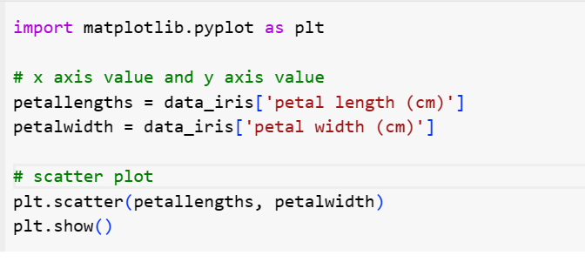

**Figure 1**

***Example of scatter plot using matplot***

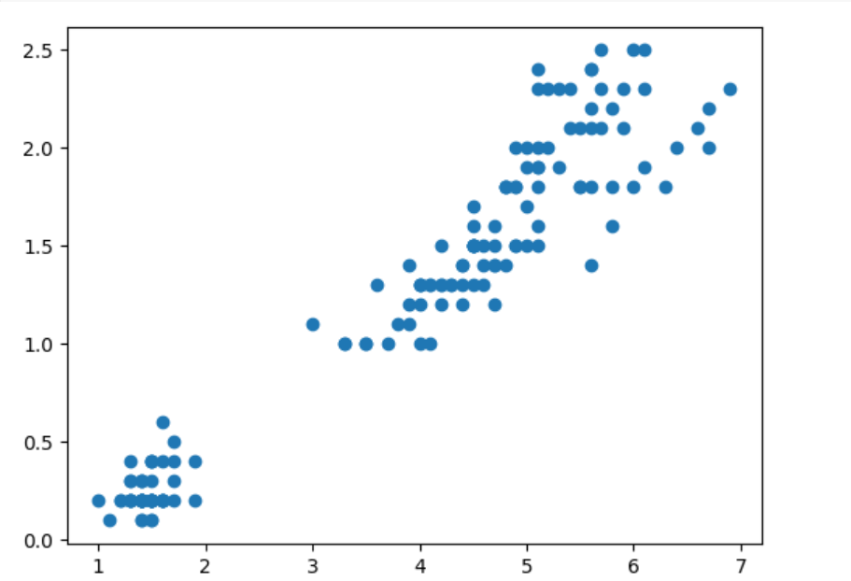

***Using Seaborn:***

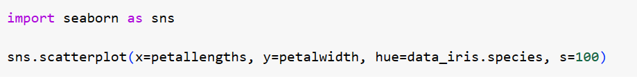

**Figure-2**

***Example of scatter plot using Seaborn***

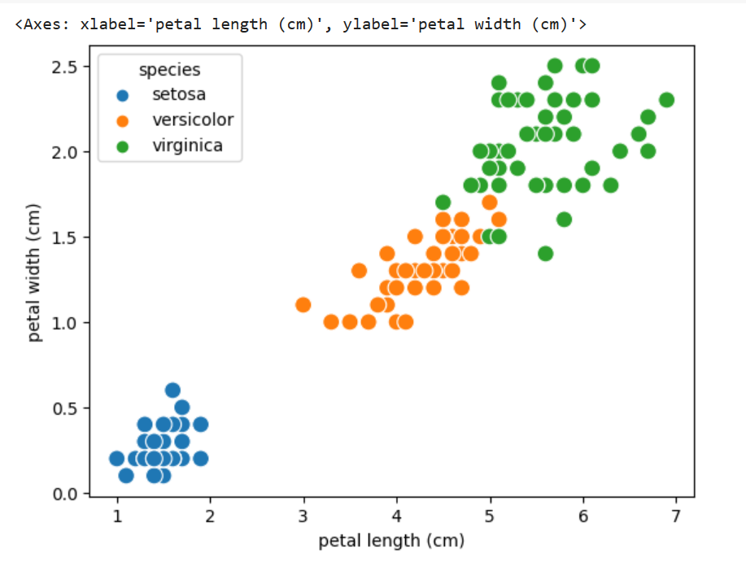

From the above plots one scatter plot is from matplotlib which is of 5 lines and second one from seaborn, plotted same graph with greater visualization and in one line of code.

For further reference you can find more explanation at Matplotlib vs. Seaborn [2]

**Folium Library**

The Folium library comes into play when we are doing analysis of regions. For example, in this case the main reason to consider this library is, the data has two columns latitude and longitude. When we are searching for a location to open the restaurant, deciding the city is one step and which side of the city is best suited is also required to consider while choosing the location.

Its main usage is to visualize geographical data, or you can say for creating maps to analyse data over a wide range of locations.

Consider the example below:

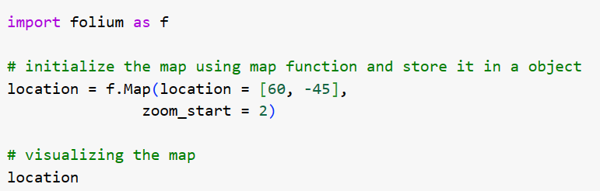

**Figure-3**

***Image of global map created through Folium library***

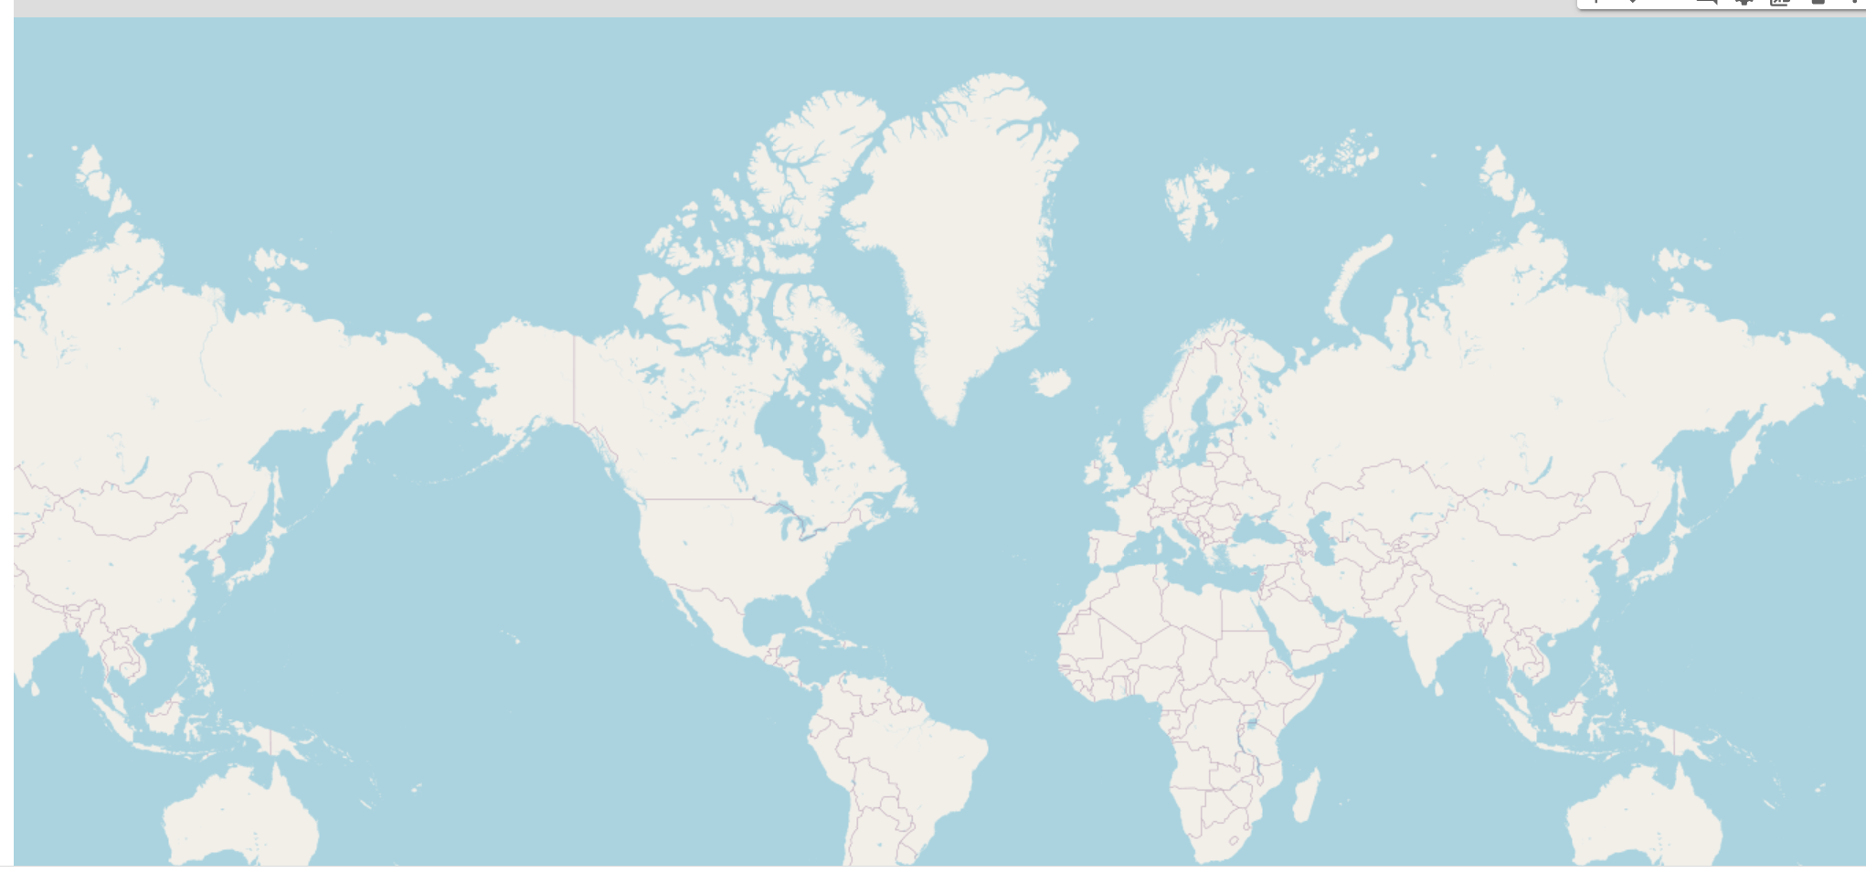

***folium.map*** function is used create map and it takes location or co-ordinates as input.

For more details and explanation visit Visualizing Geospatial Data using Folium in Python[4]

**Data Description**

We have downloaded the dataset from GITHUB which contains 20 columns, 9,550 rows in table. It has three different data types like int, float, strings.

**Dataset Fields:**

* **Restaurant ID:** Identification number of the Restaurant (Unique).
* **Restaurant Name:** Name of the Restaurant.
* **Country Code:** Each country given a numeric value.
* **City:** City name in that country.
* **Address:** Address of the restaurant.
* **Locality:** Locality of the restaurant.
* **LocalityVerbose:** City and locality combined.
* **Longitude:** Geographical Position.
* **Latitude:** Geographical Position.
* **Cuisines:** Cuisines served by the restaurants.
* **Currency:** Currency of the country where restaurant is located.
* **Has_Table_booking:** Whether the restaurant provides table booking.
* **Has_Online_delivery:** Where the restaurant provides online delivery.
* **Is_delivering_now:** Is the restaurant currently delivering.
* **Switch_to_order_menu:** Whether the restaurant switches to order menu.
* **Price_range:** Price range for the food.
* **Votes/Number of people rated:** Number of people gave rating.
* **Average_Cost_for_two:** Average cost for two people.
* **Rating:** Overall rating of the restaurant.
* **Datekey_Opening:** Opening date of the restaurant.
* **Country:** Country Name.

The dataset contains comprehensive information about restaurants, including unique IDs, names, locations (country, city, address, locality), geographic coordinates, cuisine types, pricing details (currency, price range, average cost), reservation and delivery options, ratings, votes, and opening dates. This dataset provides valuable insights into dining establishments, enabling the analysis of culinary trends and customer preferences.

**Data Transformations/ Exploratory Data Analysis**

As a first step we are creating a data frame using the pandas’ library. The restaurant data can be downloaded here Dataset [1]. By using head () function we can view the data frame that was created.

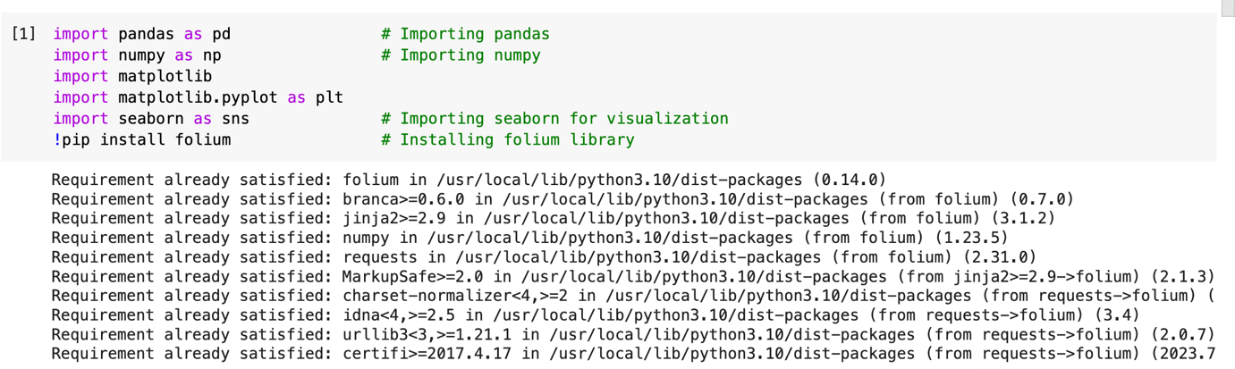

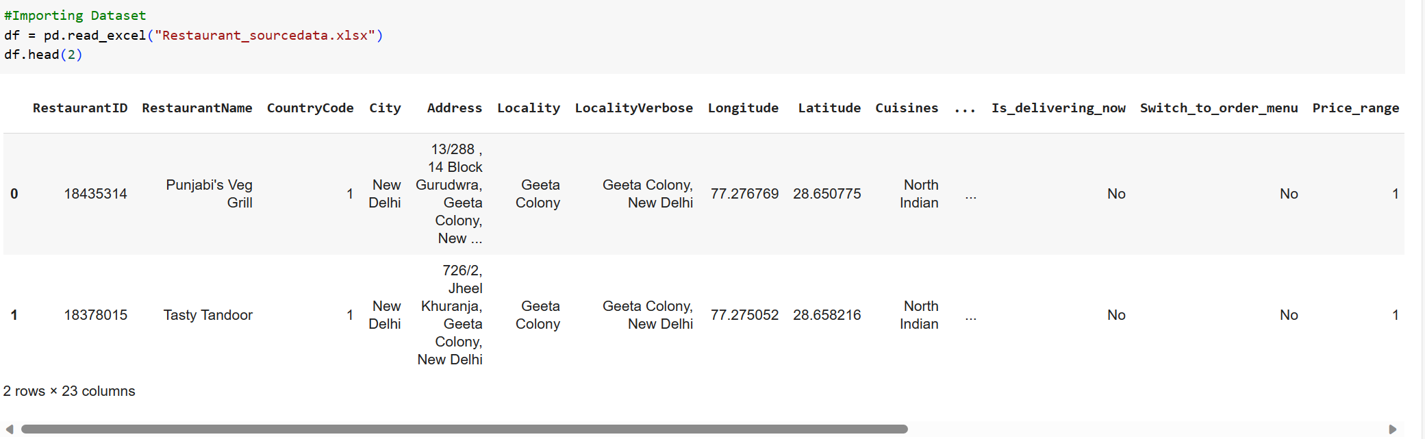

**Result:**

The above results show that data frame index always starts from 0.

Similarly the last two rows in the data frame can be displayed using **tail()** function.

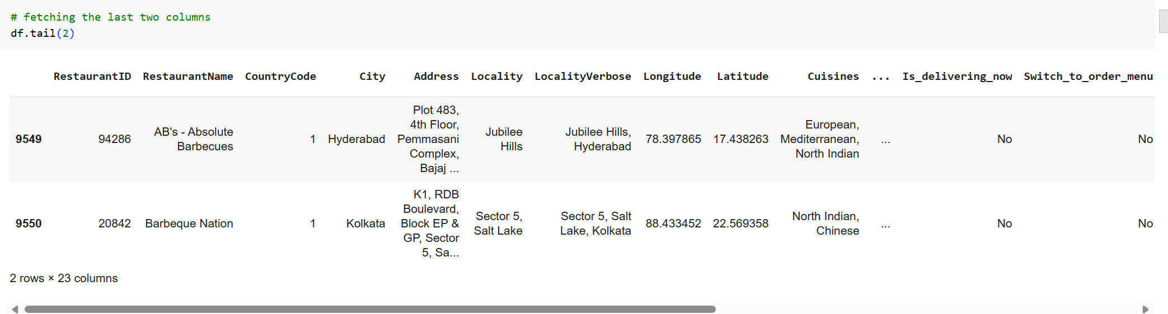

**Shape ()** function is used to see the shape of the data frame. It returns number rows and columns that are presented in the data frame.

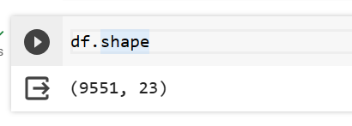

**Result:**

There are 9551 number of rows and 23 columns.

To see the column names and type of the data that are presented in the columns can be displayed using the shape function on data frame.

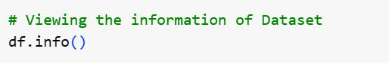

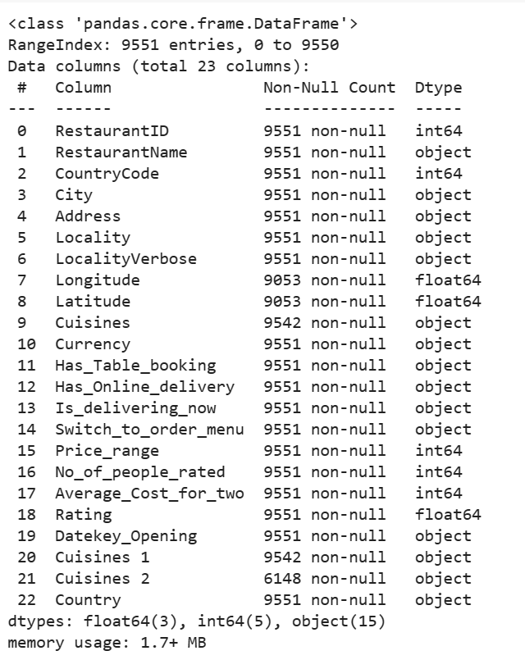

**Result:**

As said earlier index starts from 0 to n-1 where n is number of columns and we can see that most of the columns, which are strings in the data set are converted to Object type and we can also observe there are int and float data types as well.

We are creating a column named Years_in_Business which represents number of years since the restaurant is opened. The performing some actions on the ‘datekey_opening’ column since it is object type and contains month and date which is not included in any of our analysis, so we extract year from it for further calculations. Now, to calculate the Years_in_Business we need to calculate the current year and calculate the difference. This difference is added to the data frame as column. Shown in the below code.

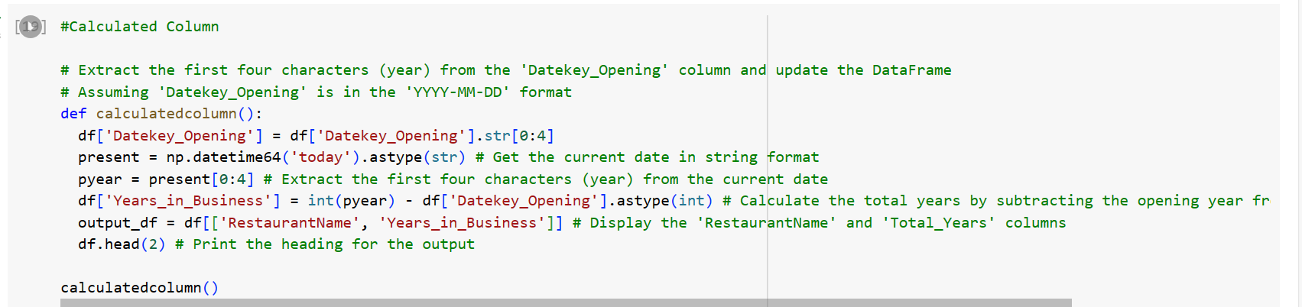

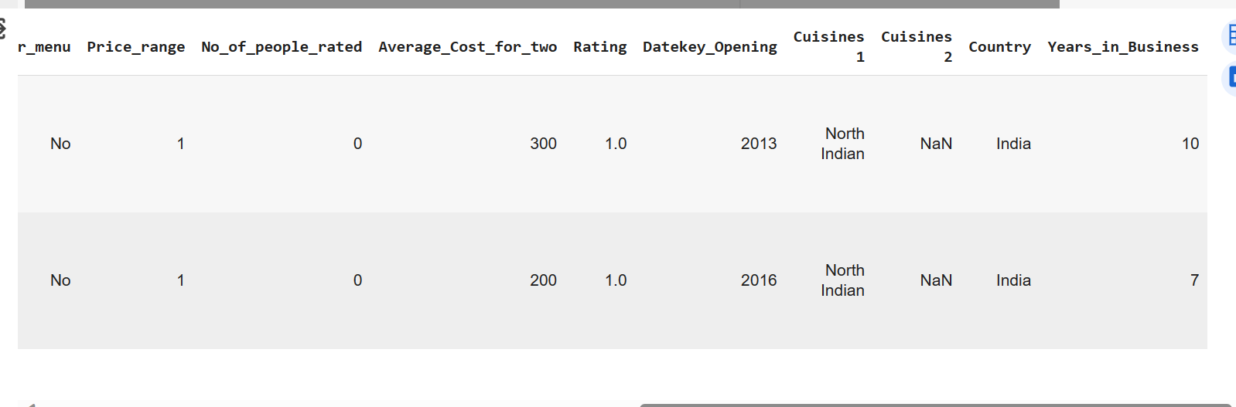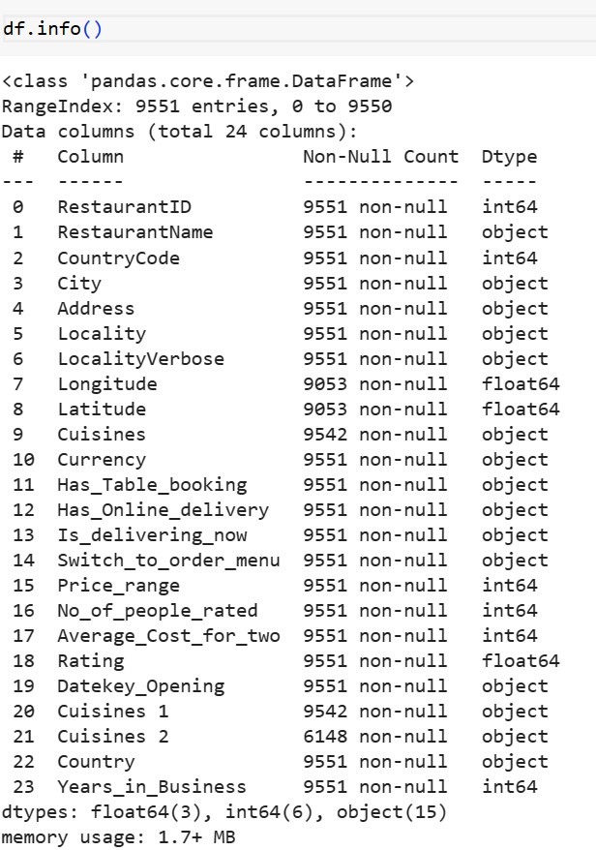

**Result:**

Observe the calculated column which is added to the data frame in the last and the values of datekey_opening is also replaced.

We manually created a data set for rating. In this data set, we assigned colours to the rating to make distinction easy on the restaurants. With these you can easily identify what rating range a restaurant falls into based on colours. The data set can be downloaded here Restaurant_Ratings [3].

Reading the data set and creating the data frame. Top 3 rows are being displayed using head() function.

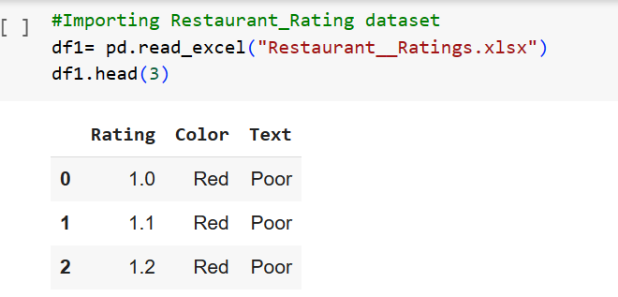

**Result:**

We can say that all the restaurants that have ratings between 1 – 2 are marked as Red.

Now, we are merging rating dataset to initial dataset to use for rest of the analysis part.

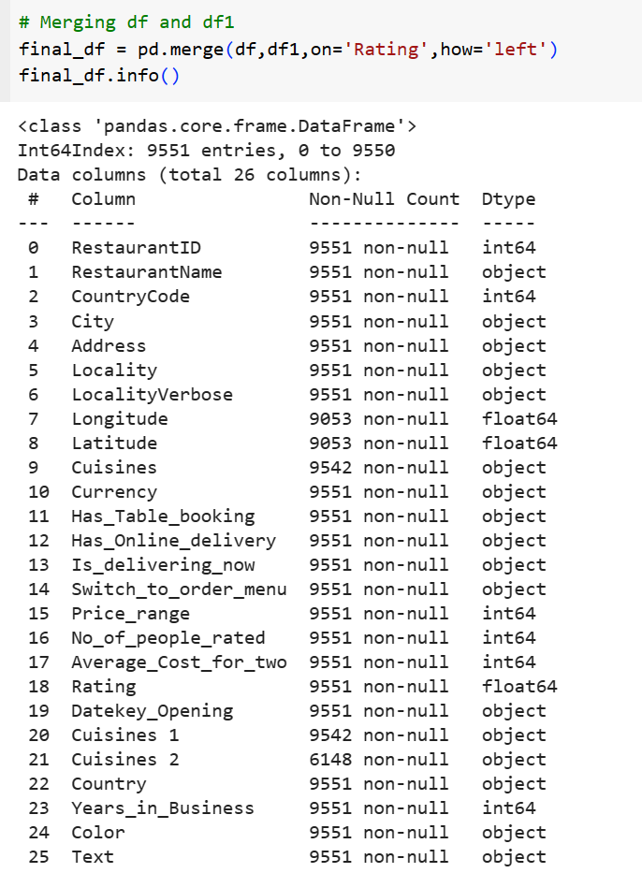

**Checking and Handling Null Values**

**isnull().sum()** helps to see how many null values are present in the data set.

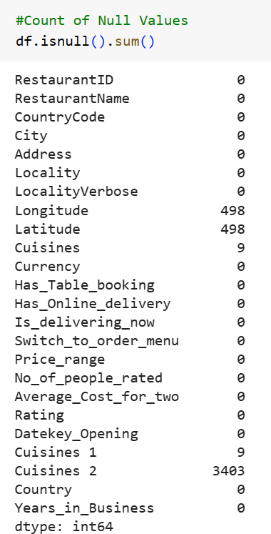

**Analysis, Findings, and Managerial Implications**

Finding the Number of Restaurants in each country so that we can filter out the best country that are suited to open the restaurant.

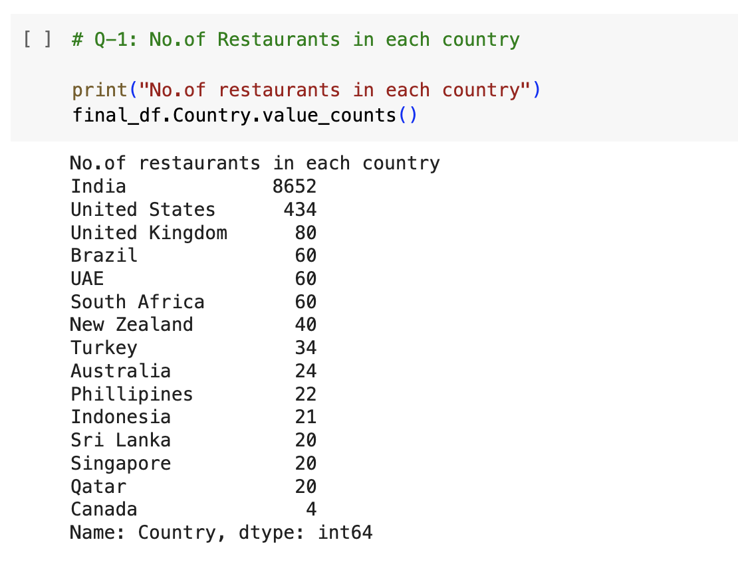

***Result:***

Recommendation we can provide is, as India has maximum number of restaurants, and market demand is high, its suggestable to open a restaurant in India.

After deciding the country, check the number of restaurants in the city and locality to decide on the location.

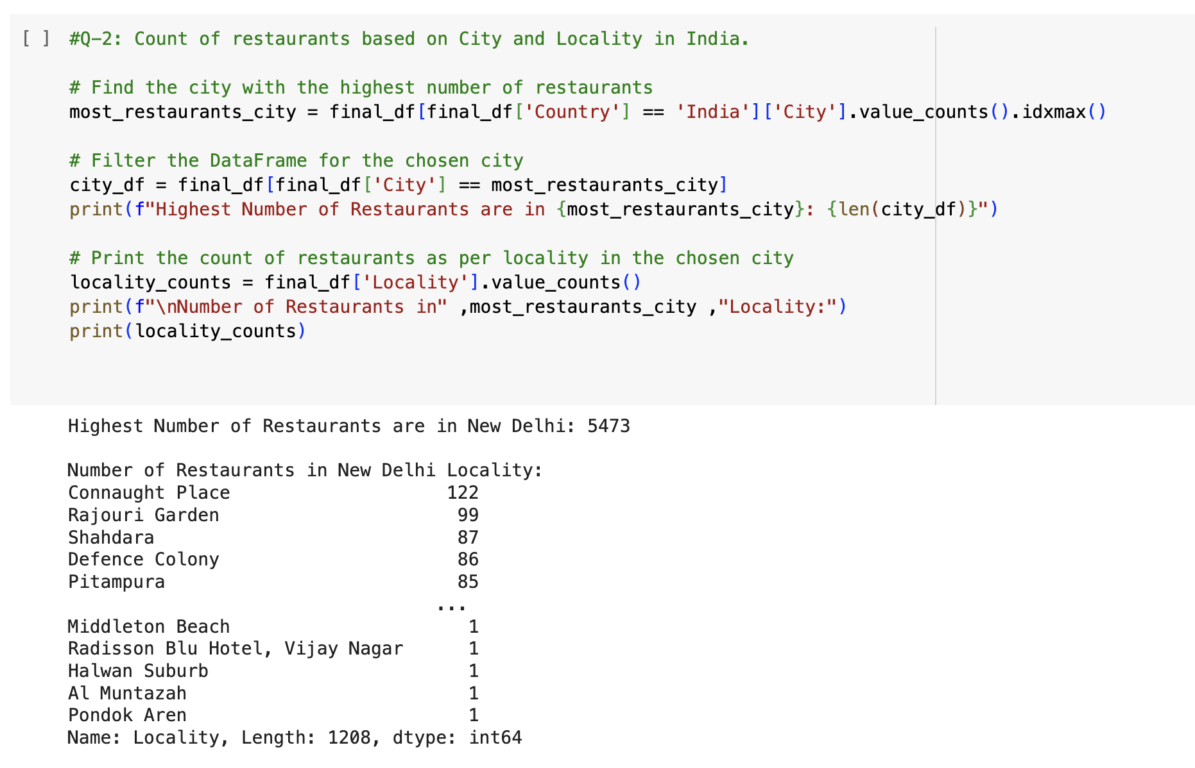

***Recommendation:***

As highest number of Restaurants are in New Delhi, start the Restaurant in New Delhi City.

Checking the density of restaurants in chosen city to check the best region to consider.

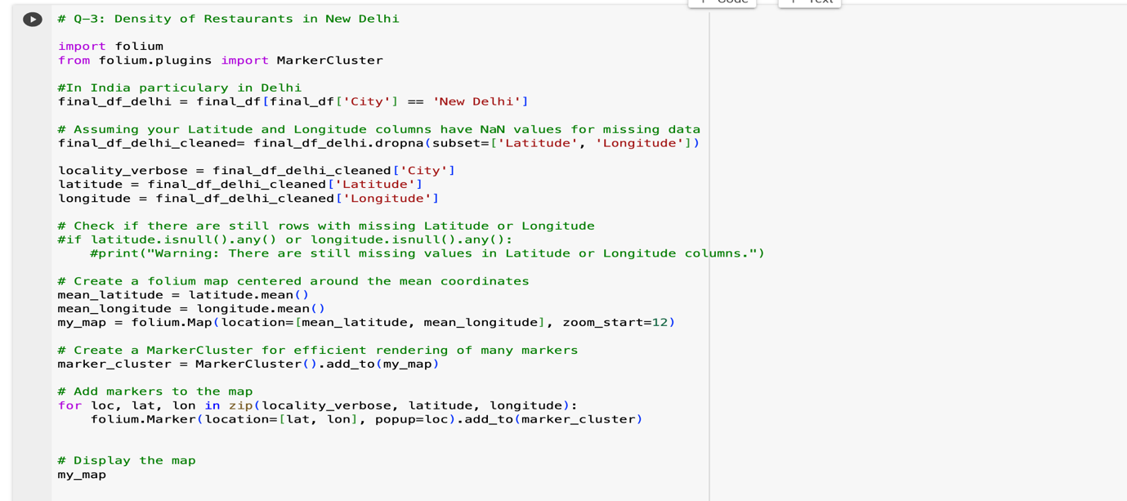

**Figure 4**

 ***A map illustrating the concentration of restaurants in various locations.***

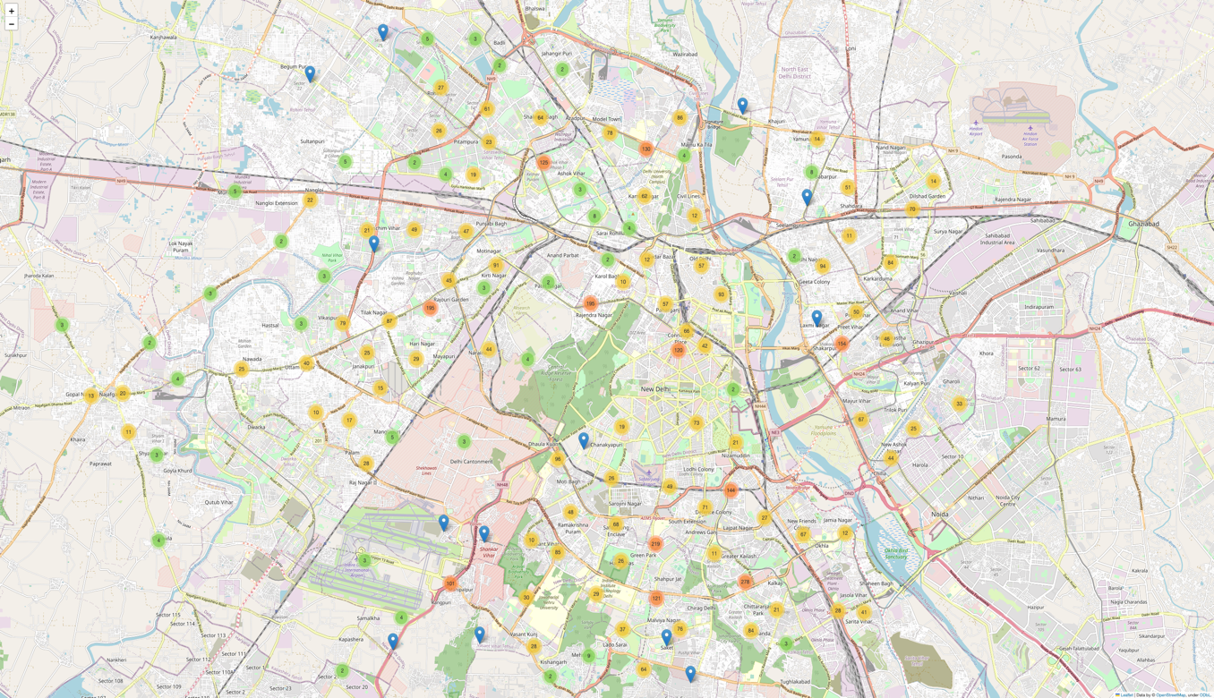

***Recommendation:***

Choose a place to open restaurant in the North-East region, where the number of restaurants is comparatively lower, offering a reduced level of competition.

Being set on location to open, next is checking the top cuisines that local people most interested to have.

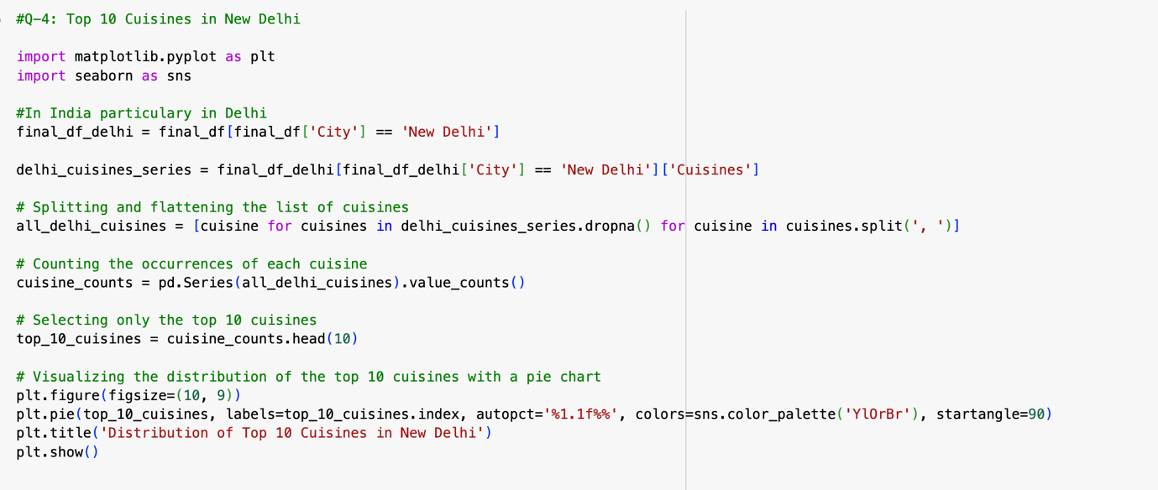

**Figure 5**

***Pie chart depicting Top 10 Cuisines distribution in New Delhi***

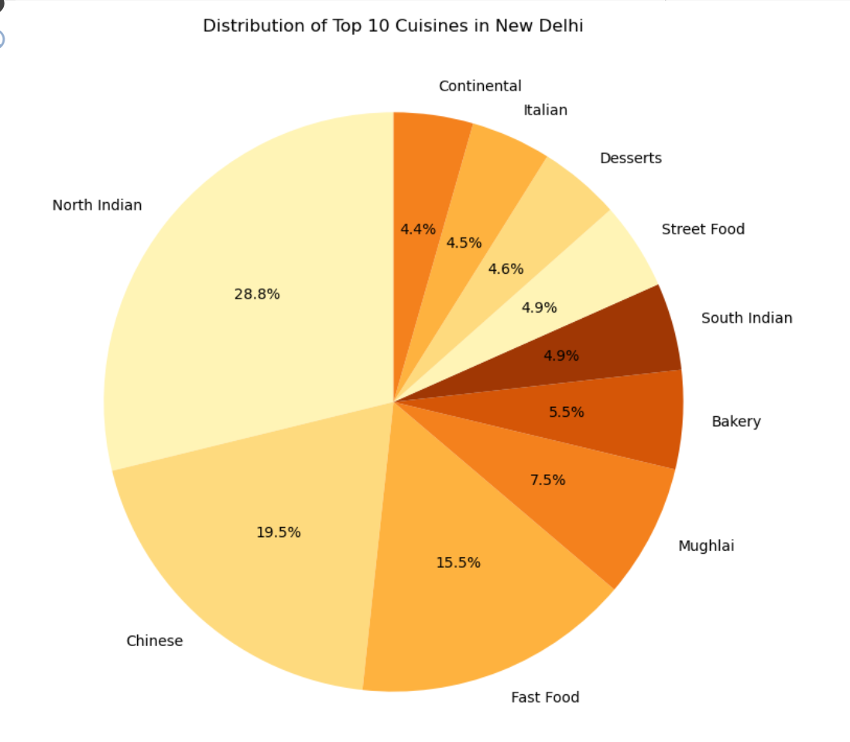

***Recommendation:***

Considering that the top three cuisines are North Indian, Chinese, and Fast food, the focus should be on offering a Fusion Cuisine, specifically an Indian-Chinese fusion.

Seeing the rating distribution of the restaurants that had been there for years and checking the most rated restaurants.

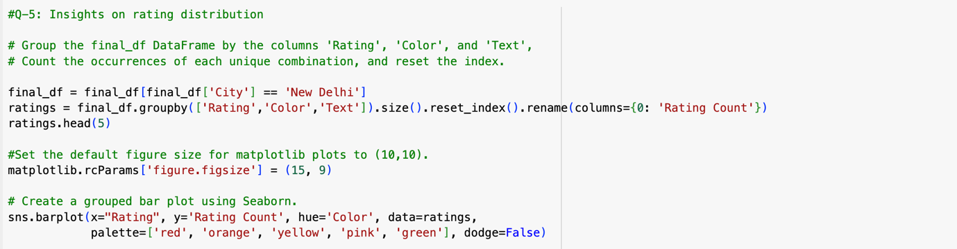

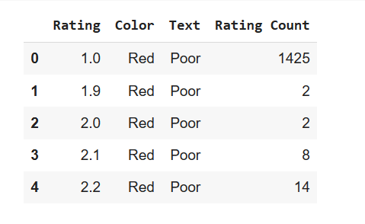

**Figure 6**

***Bar Chart depicting Restaurant Ratings vs. Number of Reviews.***

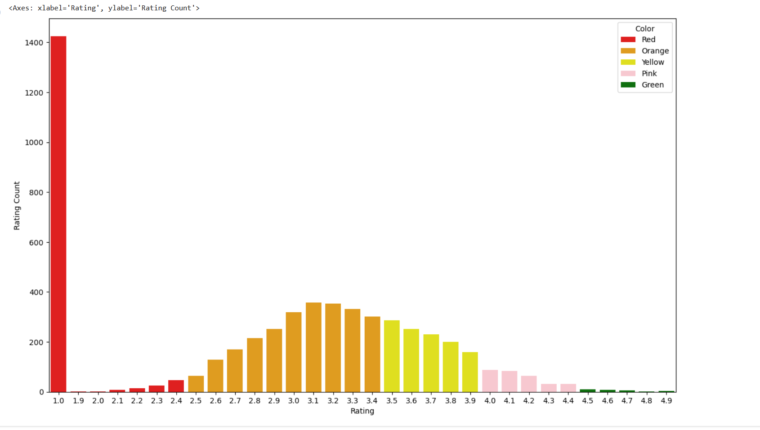

***Recommendation:***

Few restaurants with ratings above 4 exist, hence sustainable in market done through maintaining excellent food quality.

For the above question, How the average cost for two people is distributed in those restaurants?

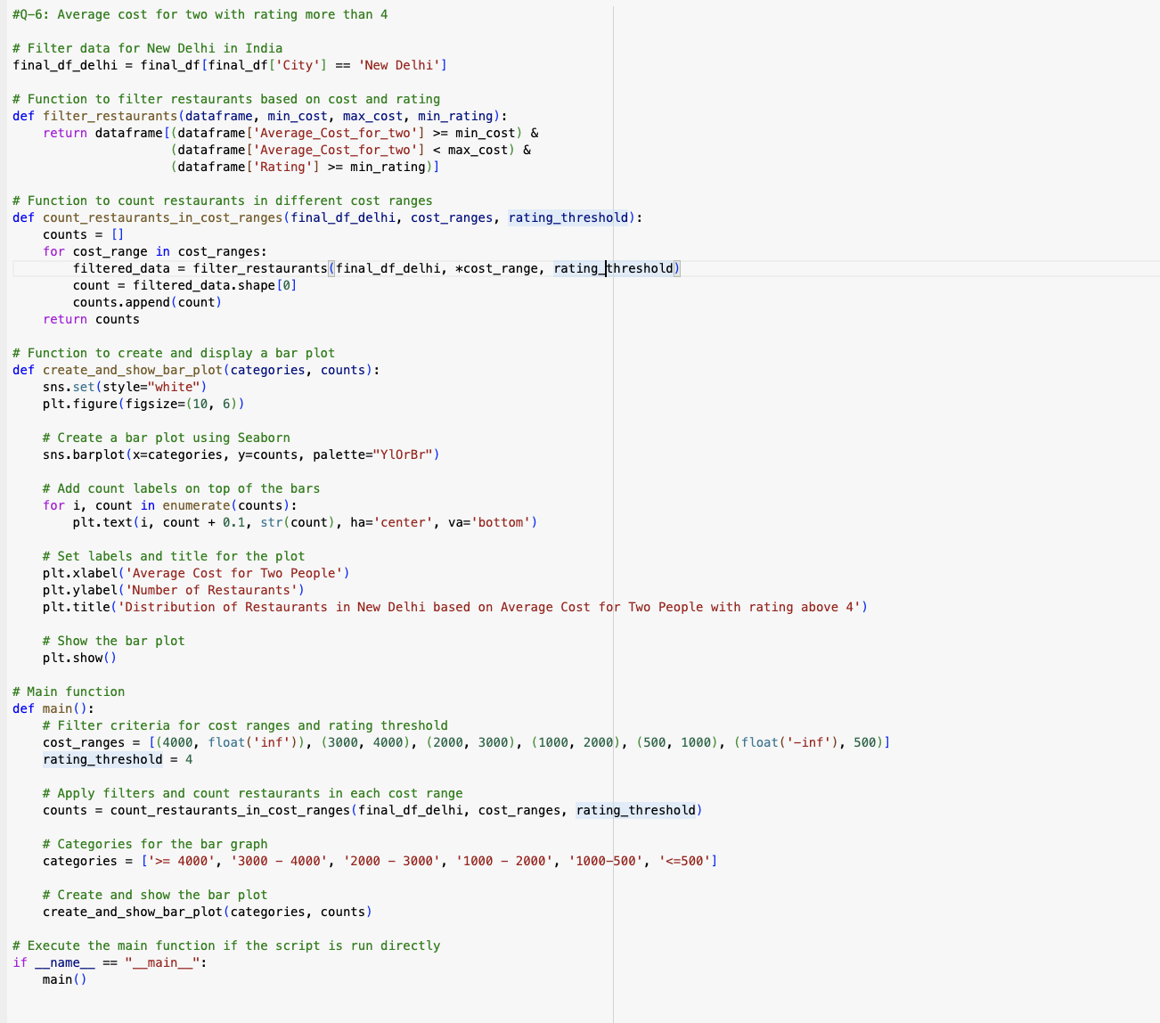

**Figure 7**

***Restaurant price distribution in New Delhi***

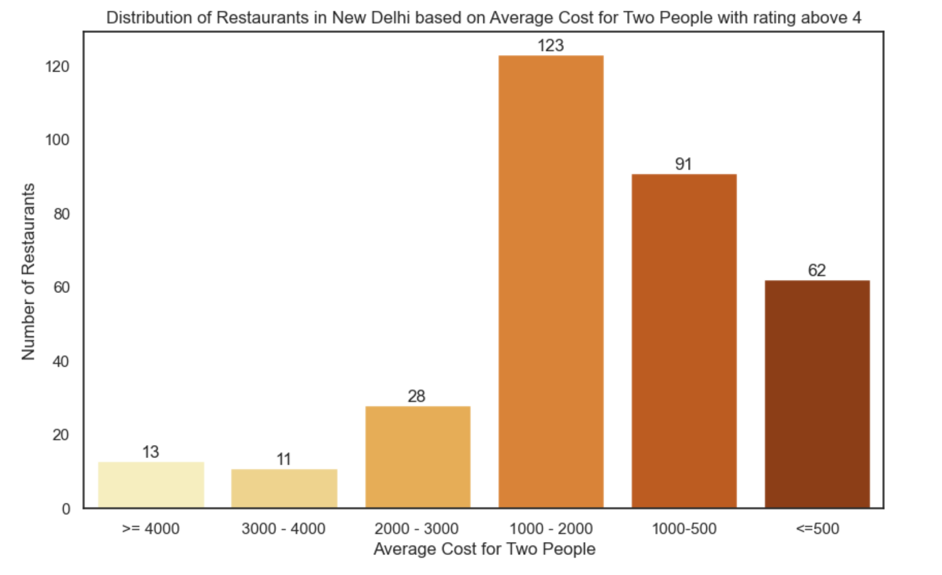

***Recommendation:***

Target the mid-priced range, with an average cost for two people falling between ₹1000 and ₹2000.

Introducing the table booking option, will introducing this option have any effect on the customers?

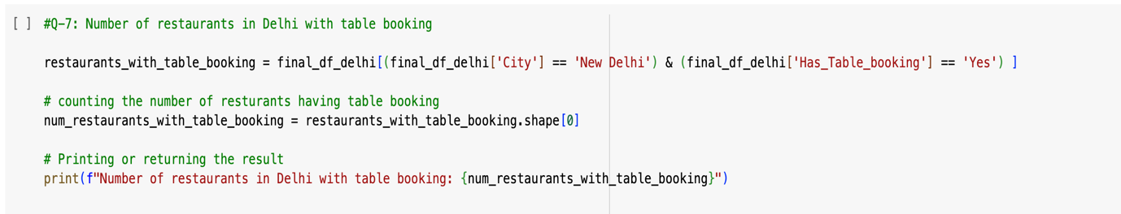

***Recommendation:***

Given that only 715 restaurants provide table booking, it is recommended to have a high seating capacity in your restaurant to secure a greater number of table bookings.

How many restaurants provide online delivery options in the filtered data?

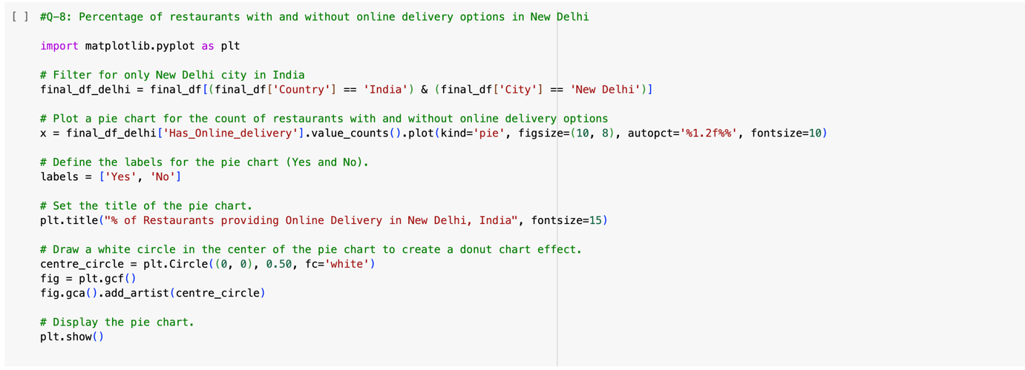

**Figure 8**

***Figure showing proportion of Restaurants offering online food services.***

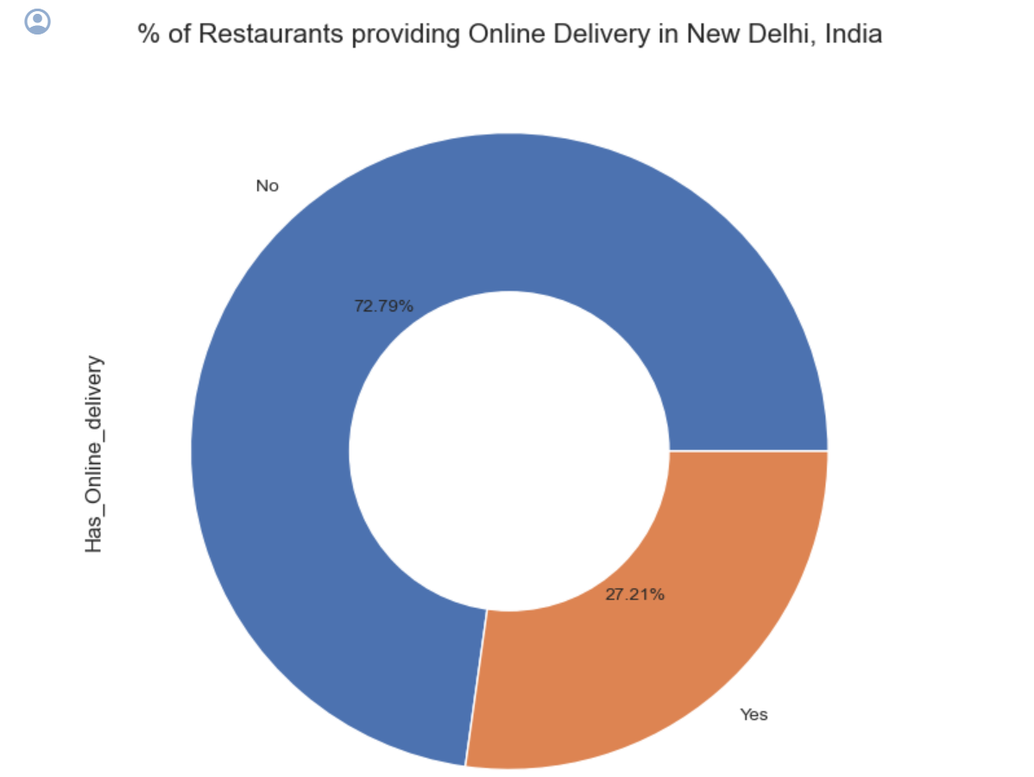

***Recommendation:***

With only 27.21% of restaurants offering online deliveries in New Delhi, expanding into the online delivery market by partnering with food platforms like Uber Eats and Swiggy, and ensuring competitive prices is advisable.

How is the online delivery option affecting the rating of the restaurant?

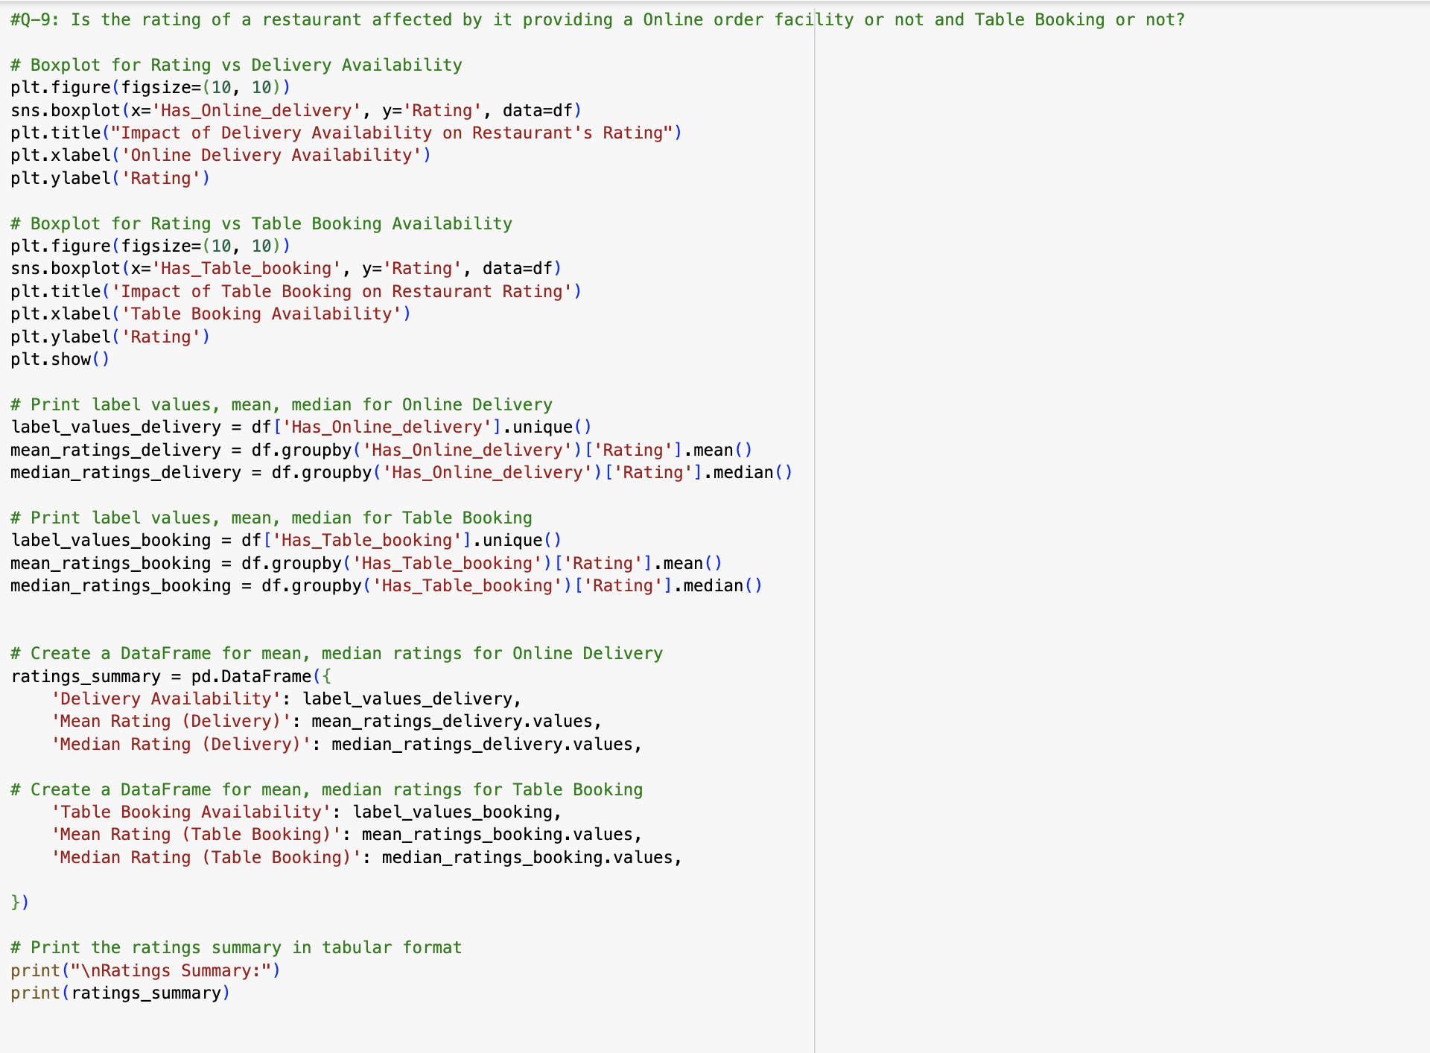

**Figure 9**

***Box plot: Online delivery's effect on restaurant ratings analysed.***

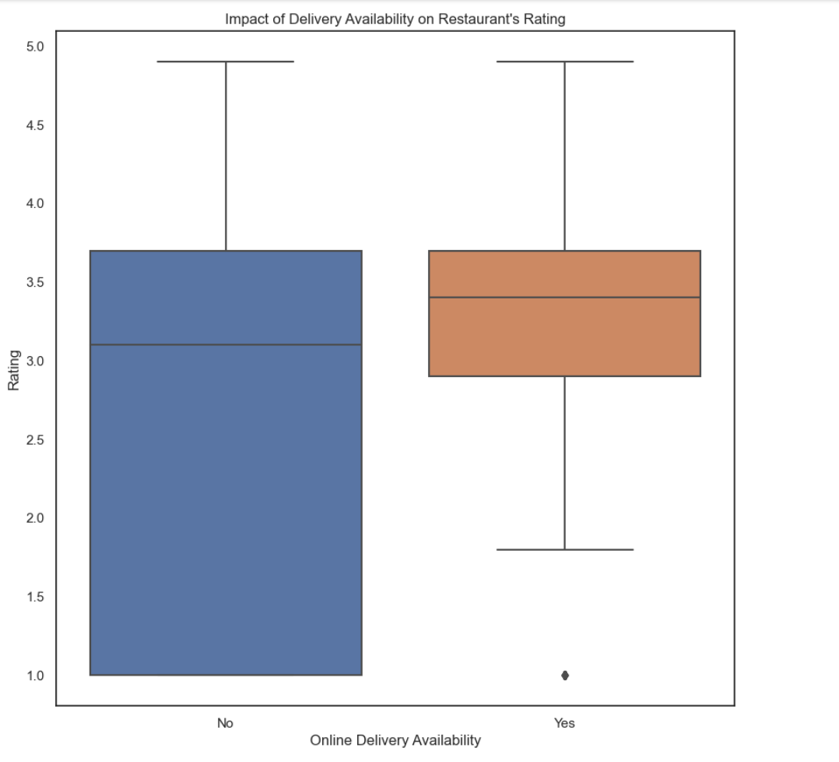

**Figure 10**

***Box plot: Table booking availability effect on restaurant ratings analysed.***

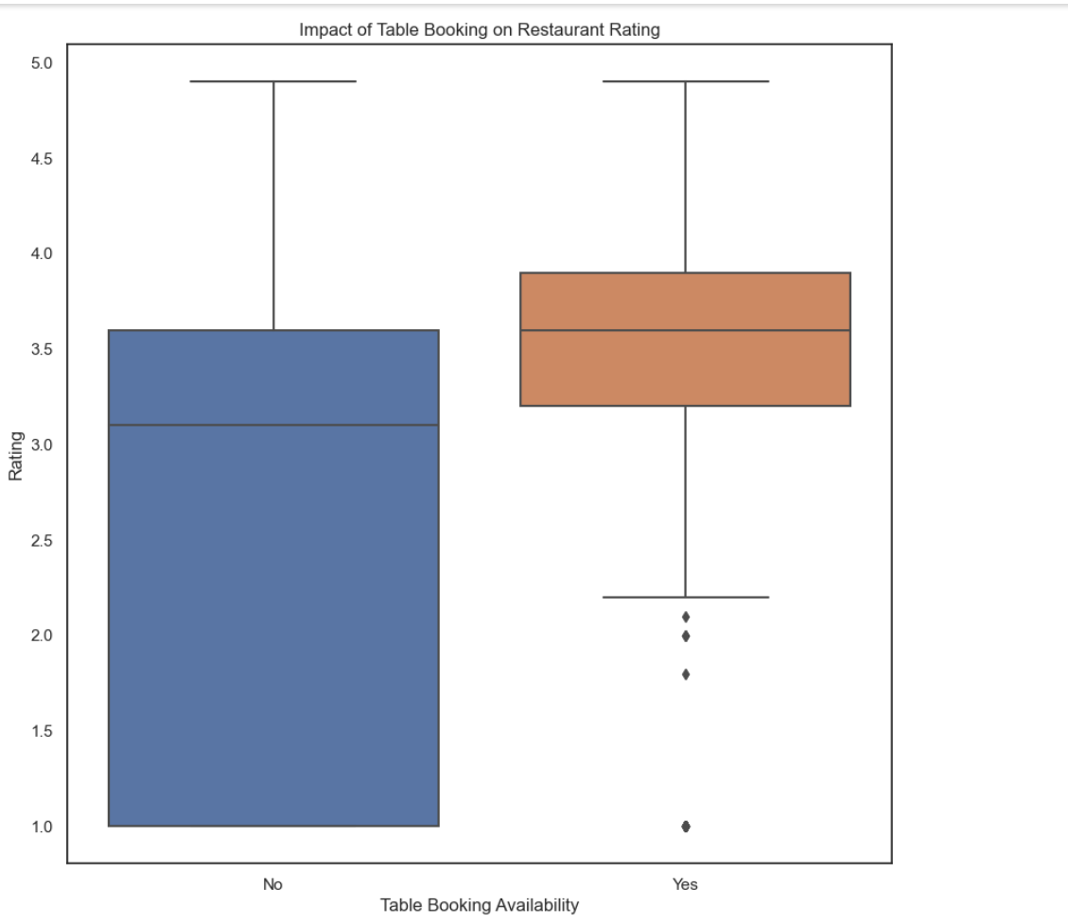

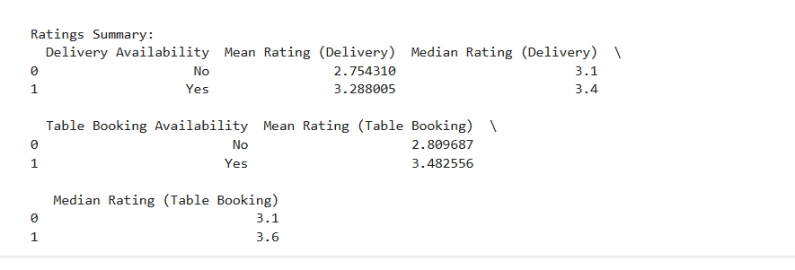

***Recommendation:***

Analysing restaurant ratings reveals that providing delivery and table booking options enhances customer satisfaction, leading to better reviews and recommendations.

Does the years in business also affecting the rating of the restaurant?

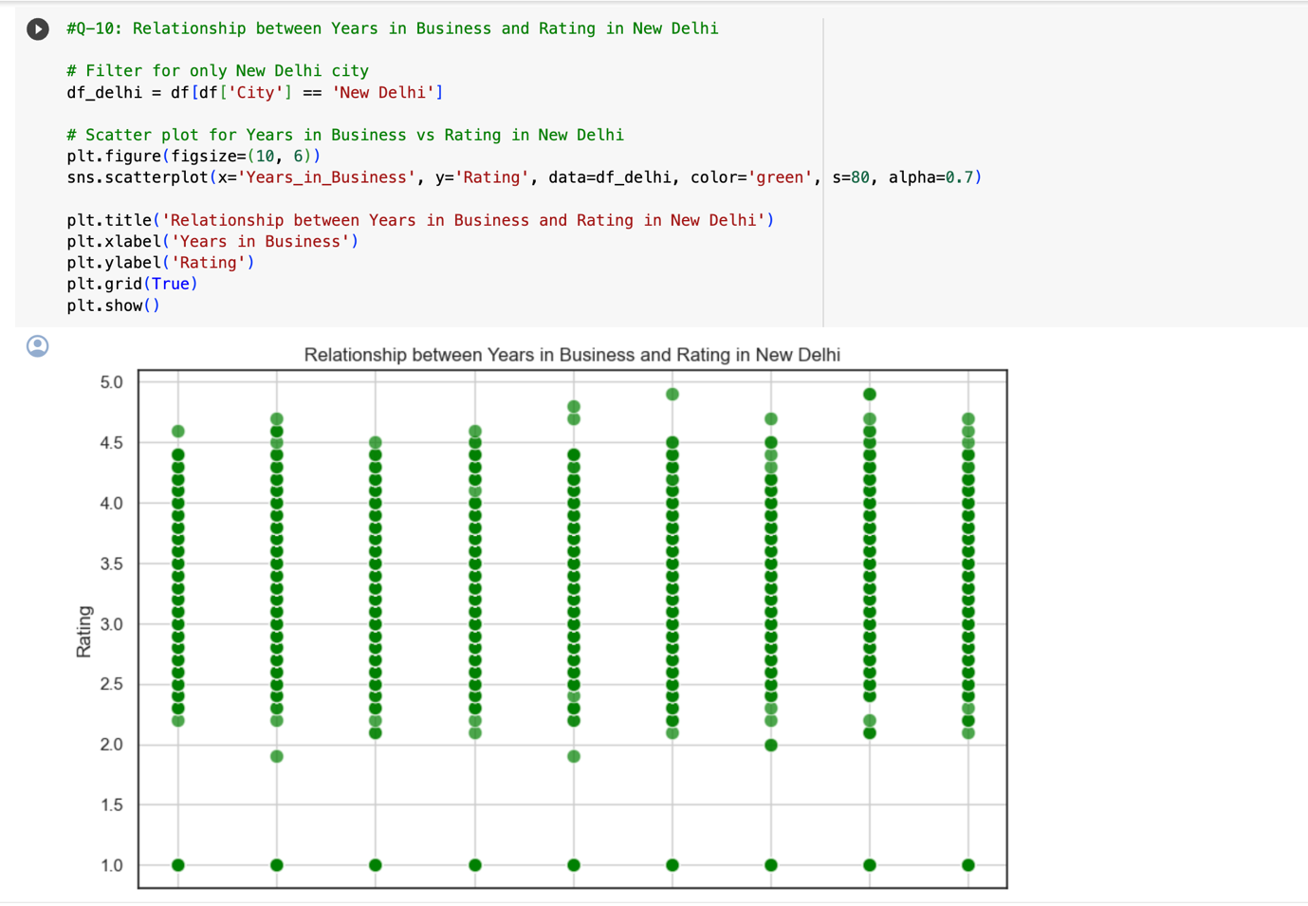

**Figure 11**

***Graph depicting the correlation of Delhi restaurant ratings over time.***

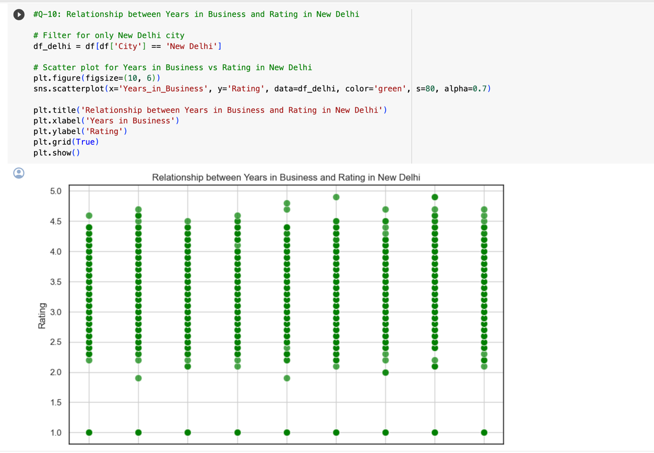

***Recommendation:***

This implies that for a restaurant to achieve a leading position with excellent ratings (above 4.5), a timeframe of five years is required.

**Conclusion**

Following an in-depth analysis, it is evident that India, particularly New Delhi, emerges as the optimal city for launching a restaurant, with a strategic focus on the Northeast region. The chosen niche is Fusion cuisine, capitalizing on the scarcity of highly rated establishments in this category and emphasizing sustainability through the consistent delivery of exceptional food quality. Targeting the mid-priced range, with an average cost for two people ranging from ₹1000 to ₹2000, is deemed strategic. To tap into the burgeoning online delivery market, collaboration with major food platforms is imperative, coupled with a commitment to competitive pricing strategies.

Significantly, the data reveals that restaurants offering table booking services, with an average rating of 3.482, outperform those without (average rating: 2.809), highlighting customer preference for reservation options, particularly in bustling cities like New Delhi. Additionally, establishments providing online delivery, boasting a mean rating of 3.288, surpass those lacking this service (mean rating: 2.754), underscoring the growing customer inclination towards convenient dining experiences. Achieving top ratings, exceeding 4.5, necessitates a substantial five-year commitment, emphasizing the long-term dedication required for establishing and maintaining a highly regarded reputation in the market.

**Appendix**



****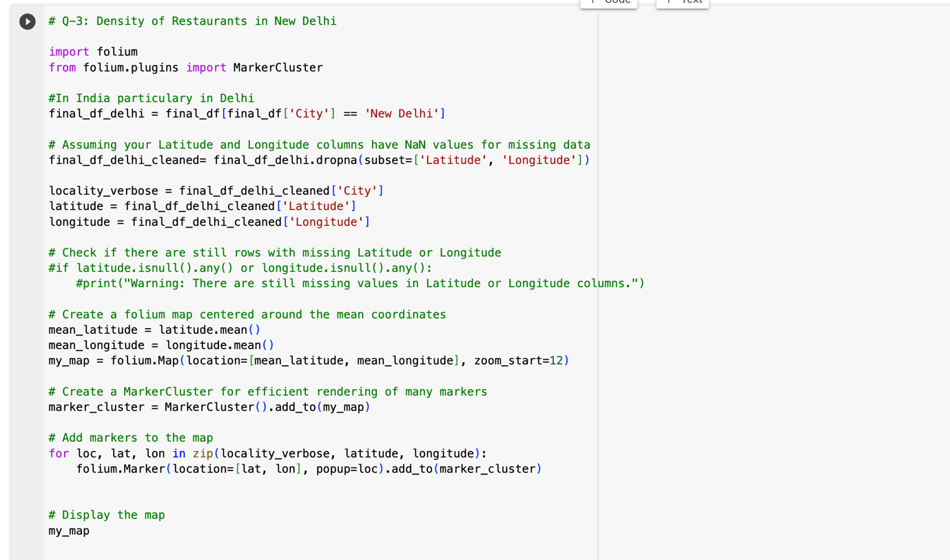







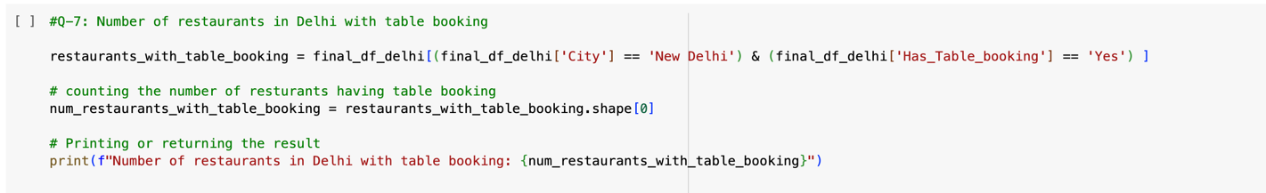

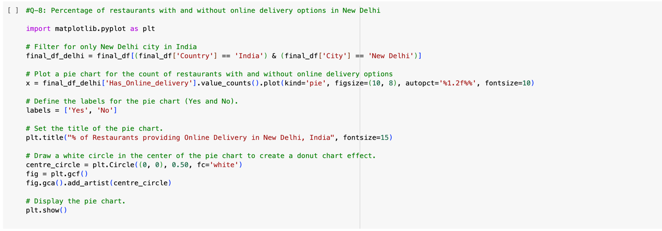



**References**

1. Dataset- [https://github.com/owaiz99/Zomato-Restaurants-Analysis-using-Excel-Sql-PowerBI-and-Tableau./blob/main/zomato data.xlsx](https://github.com/owaiz99/Zomato-Restaurants-Analysis-using-Excel-Sql-PowerBI-and-Tableau./blob/main/zomato%20data.xlsx)
2. Matplotlib vs. Seaborn - <https://codesolid.com/matplotlib-vs-seaborn/>
3. Restaurant_Ratings- [https://docs.google.com/spreadsheets/d/1_9Ho2bwekR-2ryciv3NssTqw38Qy5TN4YDh7M2Qw3zc/edit - gid=1949313755](https://docs.google.com/spreadsheets/d/1_9Ho2bwekR-2ryciv3NssTqw38Qy5TN4YDh7M2Qw3zc/edit#gid=1949313755)
4. Folium-<https://www.geeksforgeeks.org/visualizing-geospatial-data-using-folium-in-python/>